**Full Stack Development CS603**

**MINI PROJECT REPORT**

on

**Rental Car Booking System**

*Submitted by*

**M. Rupa Naga Lakshmi(2021BCSE07AED059)**

**A. Satwik Reddy (2021BCSE07AED495)**

*In partial fulfillment of the award of the degree of*

**BACHELOR OF TECHNOLOGY**

In

**COMPUTER SCIENCE AND ENGINEERING**

*Under the Supervision of*

**Prof. Sengottaiyan N**



**ALLIANCE COLLEGE OF ENGINEERING AND DESIGN**

**ALLIANCE UNIVERSITY, BENGALURU**

**MARCH - 2024**



# CERTIFICATE

This is to certify that the mini project work entitled “**Car Rental Booking System**” is the bonafide work done by M. **Rupa Naga Lakshmi (2021BCSE07AED059, A. Satwik Reddy (2021BCSE07AED495),** submitted in partial fulfillment of the requirements for the award of the degree Bachelor of Technology in Computer Science and Engineering during the year 2023-2024

Guide: Prof. Sengottaiyan U

Assistant Professor, CSE

**ABSTRACT**

The HTML project that is being provided provides an overview of an extensive online application for booking vehicle rentals. It includes important features like search for cars, making reservations, authenticating users, and handling payments. With its simple form inputs and navigation, the frontend design guarantees a flawless user experience. Customers can quickly look up available vehicles, book them, obtain support contact details, and log into their accounts.

To make the booking process easier, consumers can choose their preferred dates, pick-up and drop-off locations, and automobile types in the reservation area. In order to ensure flexibility and security in transactions, the application also supports a number of payment options, such as PayPal, debit cards, and credit cards (Visa, MasterCard, American Express).

Secure access to user-specific services, like payment dashboards and reservation histories, is made possible via user authentication capability. Users receive confirmation messages after a booking is successful, thanking them for their selection. To improve customer experience and operational efficiency, the web application for booking car rentals incorporates a number of extra features.

By allowing customers to narrow down their automobile searches according to particular parameters like make, model, fuel type, and amenities, advanced search filters enable consumers to make customized rental selections. Updates on vehicle availability in real-time guarantee correct information, reducing the possibility of duplicate reservations and boosting customer confidence. Consolidated evaluations and rankings promote openness and confidence among consumers, enabling well-informed choices. Members receive special benefits and cost-effective options through subscription plans and promotional discounts, which encourage reservations.

Customer satisfaction and loyalty are increased by multi-channel support, which guarantees prompt assistance through a variety of communication channels. Dynamic pricing algorithms maximize revenue and competitiveness by optimizing rental prices based on seasonal trends and variations in demand.

In addition to guaranteeing user safety and fleet integrity, the vehicle damage reporting tool expedites the repair procedure. Recurring reservations are encouraged by integration with loyalty programs, which increases user engagement and retention. Initiatives for environmental sustainability, such as leasing hybrid or electric cars, are consistent with moral business conduct and cultural norms. In the cutthroat car rental market, these improvements are meant to provide a thorough and valuable experience.

In summary, the goal of the Car Rental Booking project is to provide an easy-to-use and effective platform for car rentals that will guarantee security and dependability all the way from reservation to payment.

**INTRODUCTION**

In the world of online vehicle rental services, the vehicle Rental Booking web application is a significant advancement as it provides a sophisticated yet approachable platform for easy rental car reservations. This app, which was developed in response to the growing need for seamless digital solutions, streamlines and makes the entire rental procedure easier in order to tackle the conventional problems related to automobile rentals. Through the use of contemporary web technologies and adherence to user experience design best practices, the platform seeks to improve accessibility and ease for users of all types, from private consumers to business clients.

The goal of providing a complete solution that meets the various needs of its user base is at the core of the Car Rental Booking project. With functions like reservation management, safe authentication, and adjustable payment methods, the app aims to provide users the means to handle the rental process with ease. The platform aims to reinvent the automobile rental experience by putting customer satisfaction and operational efficiency first. It does this by providing a degree of simplicity and dependability that makes it stand out in a sector that is becoming more and more competitive.

Additionally, in order to fulfill the changing demands of modern consumers, the Car Rental Booking application embraces innovation and digitalization, representing a progressive approach to transportation services. The platform not only makes renting a car easier, but it also raises the bar for convenience and effectiveness in the sector with its user-friendly design and strong functionality. In order to create a more connected and accessible future in transportation, the application seeks to transform the way both consumers and organizations obtain and use automobile rental services by offering a flawless online experience from beginning to end.

A brief introduction includes the following:

* There are sections dedicated to car searches, reservations, user logins, and contact details.
* For a flawless user experience, the design includes responsive layout, simple form input, and straightforward navigation.
* The reservation area contains important features like choosing dates, pick-up and drop-off locations, and automobile kinds.
* PayPal, debit cards, and credit cards are just a few of the payment options that the application accepts.
* Secure access to user-specific services, such as reservation history, is guaranteed by user authentication technology.
* Integrated are extra features including loyalty programs, environmental sustainability initiatives, and vehicle damage reporting.
* In the cutthroat car rental sector, the application seeks to provide a thorough and value-added experience.

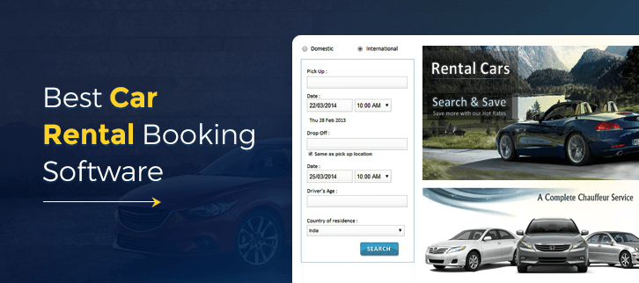



**SYSTEM REQUIREMENTS**

The system requirements of Car Rental Booking system outlines the following:

1. **Web Browser Compatibility**:
   * The application should be compatible with modern web browsers such as Google Chrome, Mozilla Firefox, Safari, and Microsoft Edge.
   * Ensure compatibility with older browser versions to accommodate a wider range of users.
2. **Server Requirements**:
   * Web server software such as Apache or Nginx to host the HTML files and serve them to clients.
   * Support for server-side scripting languages if dynamic functionality is implemented (not evident in the provided code).
3. **Database**:
   * If user authentication and reservation management involve data storage, a relational database management system (RDBMS) like MySQL, PostgreSQL, or SQLite may be required.
4. **Internet Connectivity**:
   * A stable internet connection is necessary for users to access the application and make reservations online.
   * The application may also require internet connectivity to fetch real-time data such as vehicle availability or weather forecasts.
5. **Client-Side Resources**:
   * Devices accessing the application should have sufficient processing power and memory to render HTML, CSS, and JavaScript content.
   * Support for CSS3 and HTML5 features for optimal display and functionality.
6. **Security**:
   * Implementation of HTTPS encryption is essential to secure data transmission, especially for sensitive information like user credentials and payment details.
   * Regular security updates and patches to address vulnerabilities in both server-side and client-side components.
7. **Accessibility**:
   * Ensure the application complies with accessibility standards (e.g., WCAG) to accommodate users with disabilities.
   * Use semantic HTML markup and provide alternative text for images to facilitate screen reader compatibility.
8. **Scalability**:
   * The system should be designed to handle concurrent user traffic, especially during peak booking periods.
   * Scalability measures such as load balancing and caching may be implemented to improve performance and accommodate growing user demand.
9. **Backup and Recovery**:
   * Regular backups of the application data and configuration settings to prevent data loss in case of system failures or security breaches.
   * Implementation of disaster recovery procedures to restore the application and its data in the event of a catastrophic failure.
10. **Documentation and Support**:
    * Comprehensive documentation covering installation, configuration, and usage instructions for administrators and users.
    * Provision of technical support channels (e.g., email, forums) to assist users with troubleshooting and address any issues they encounter.

Top of Form

**CODE**

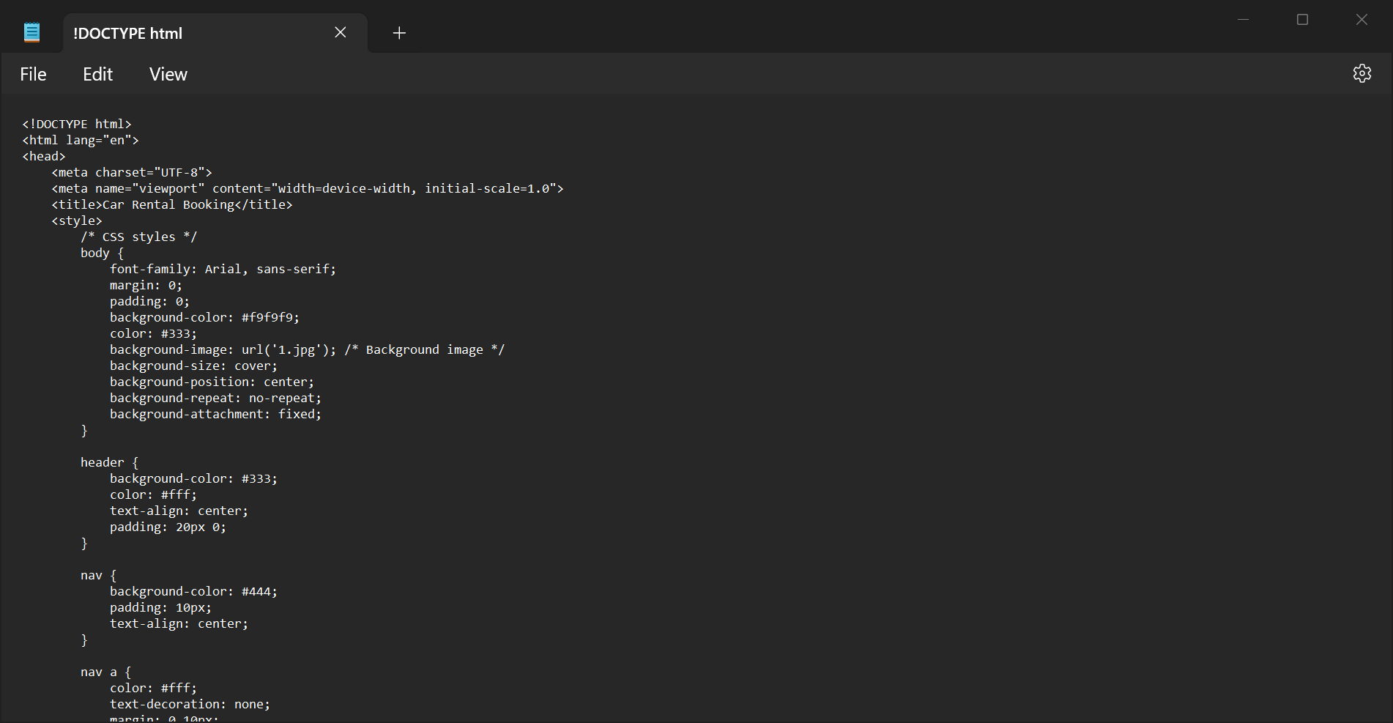

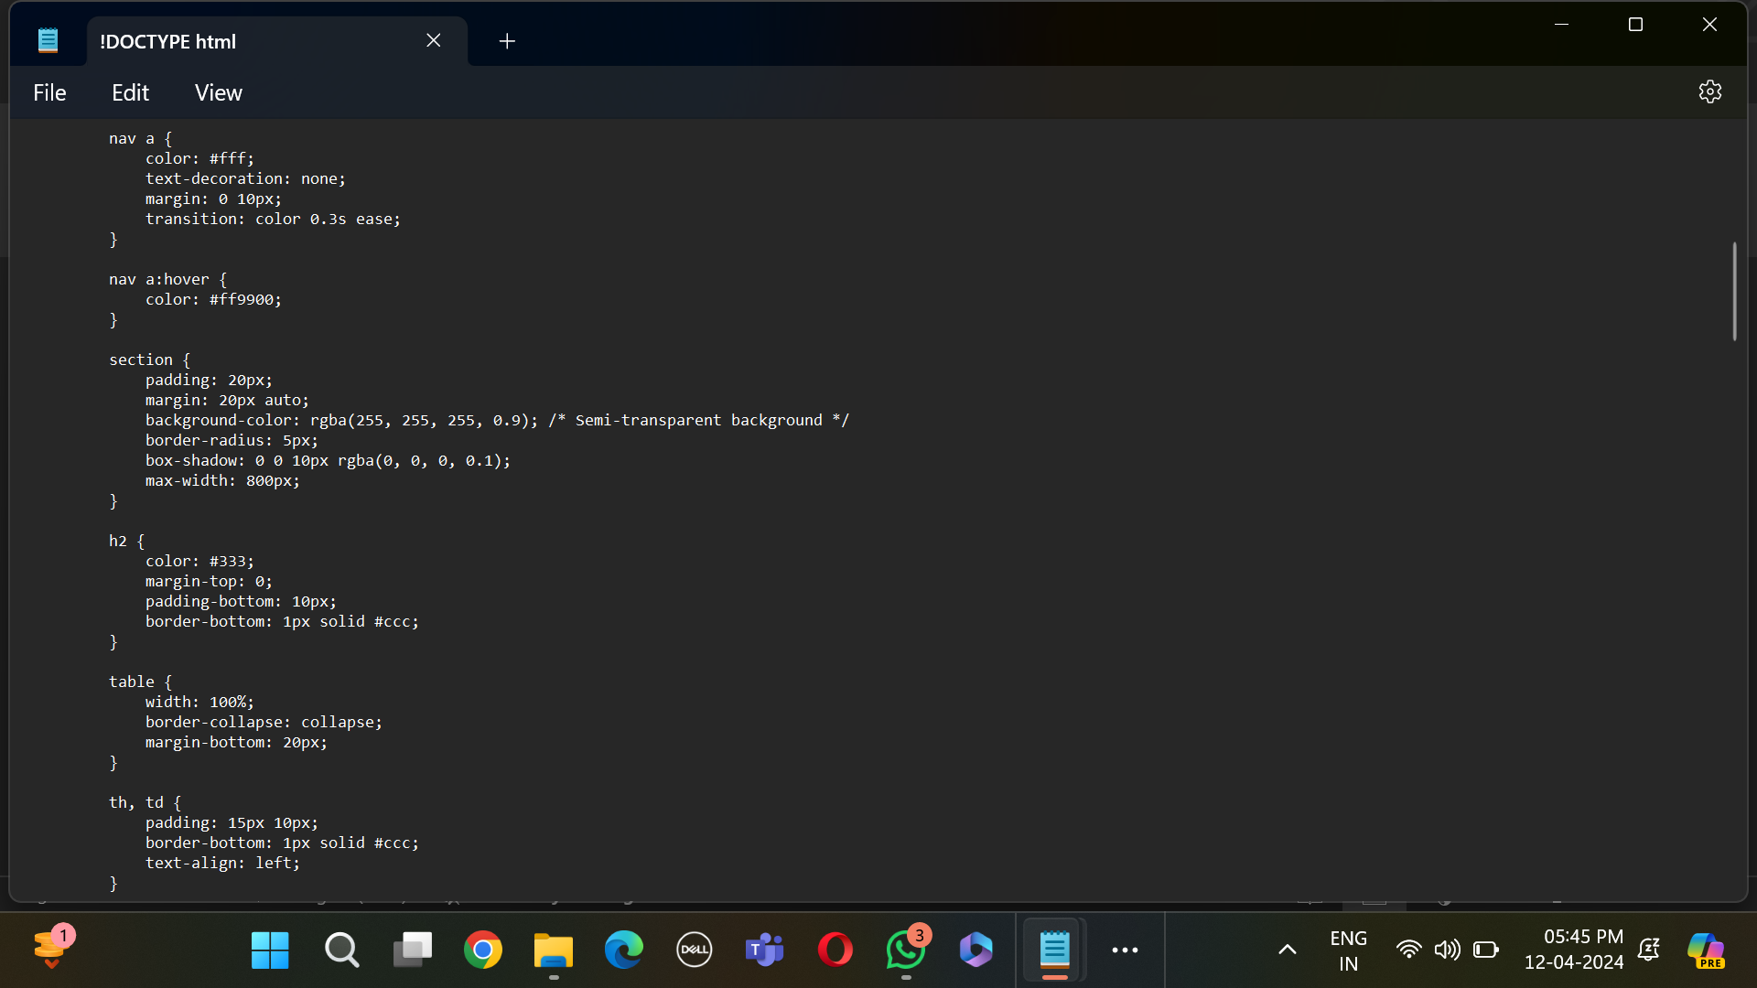

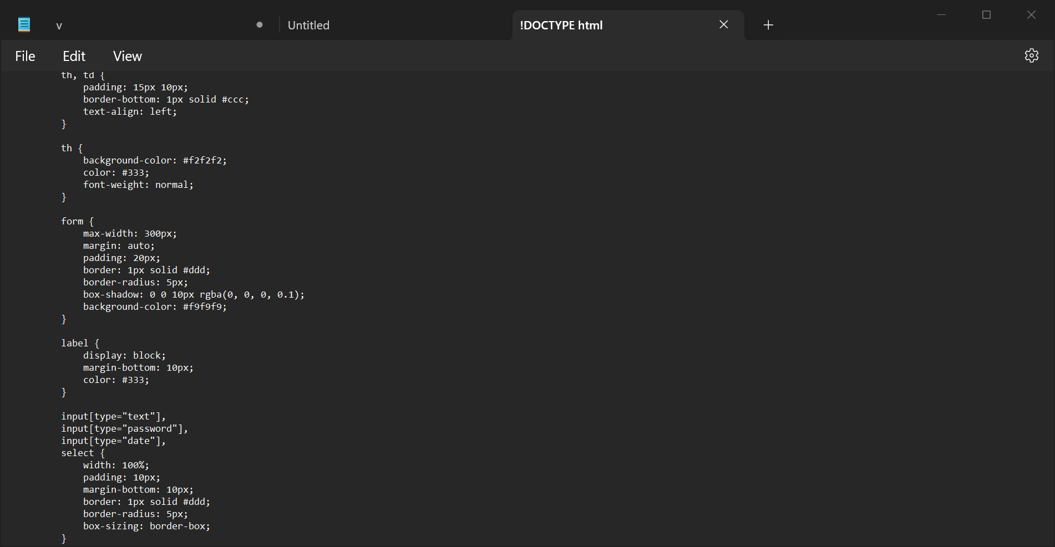

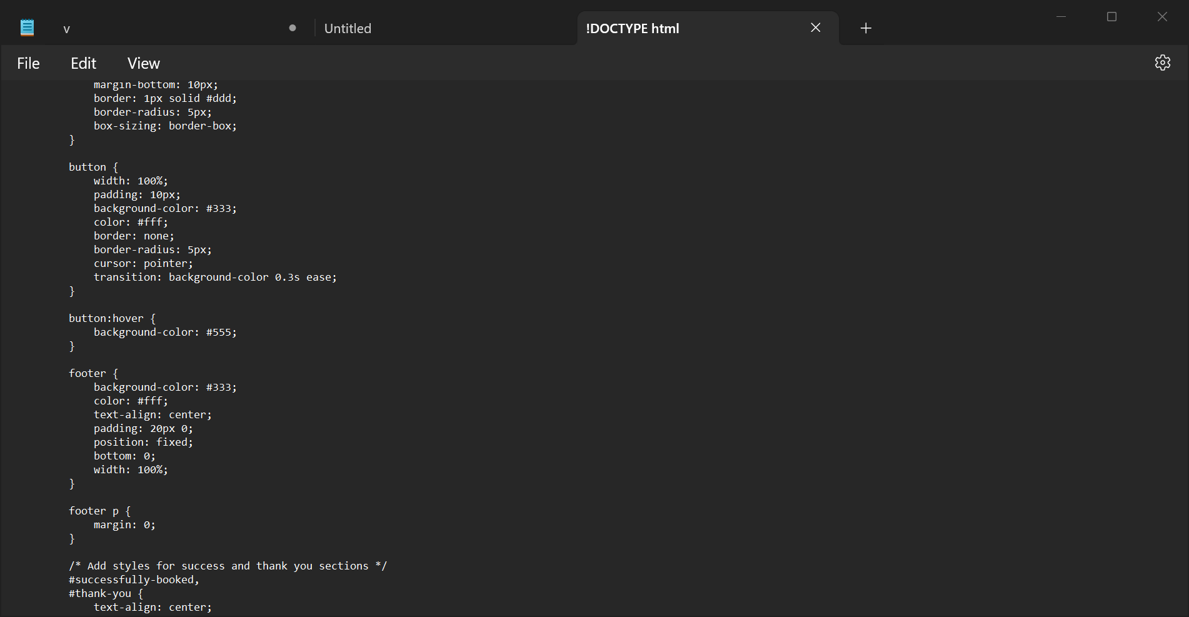

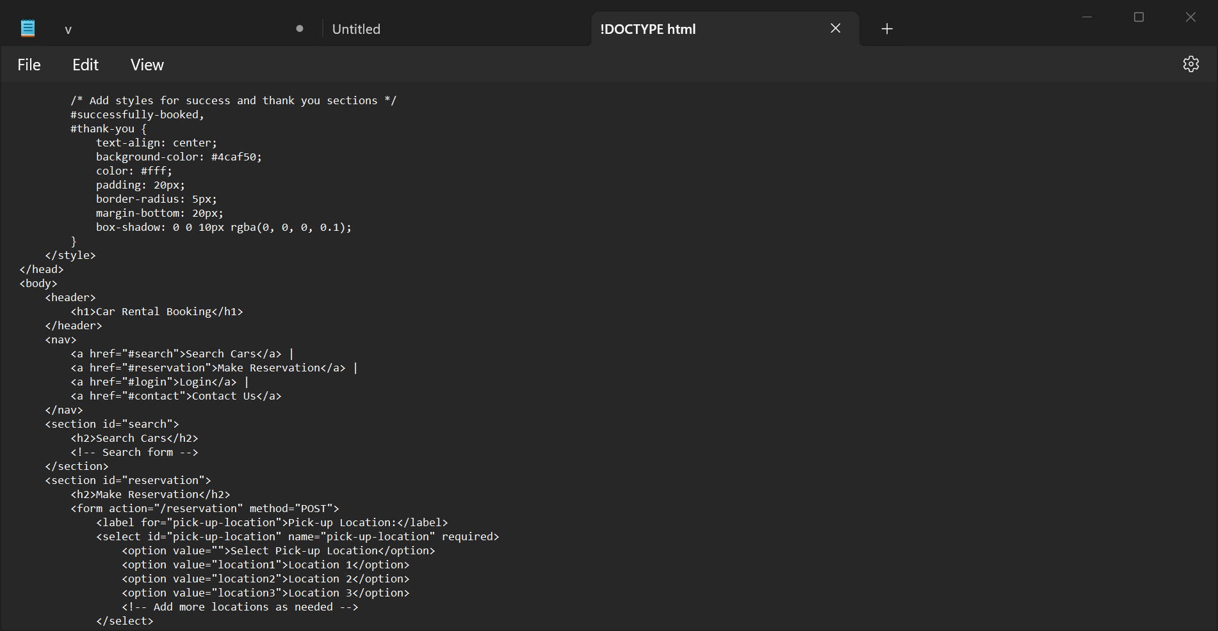

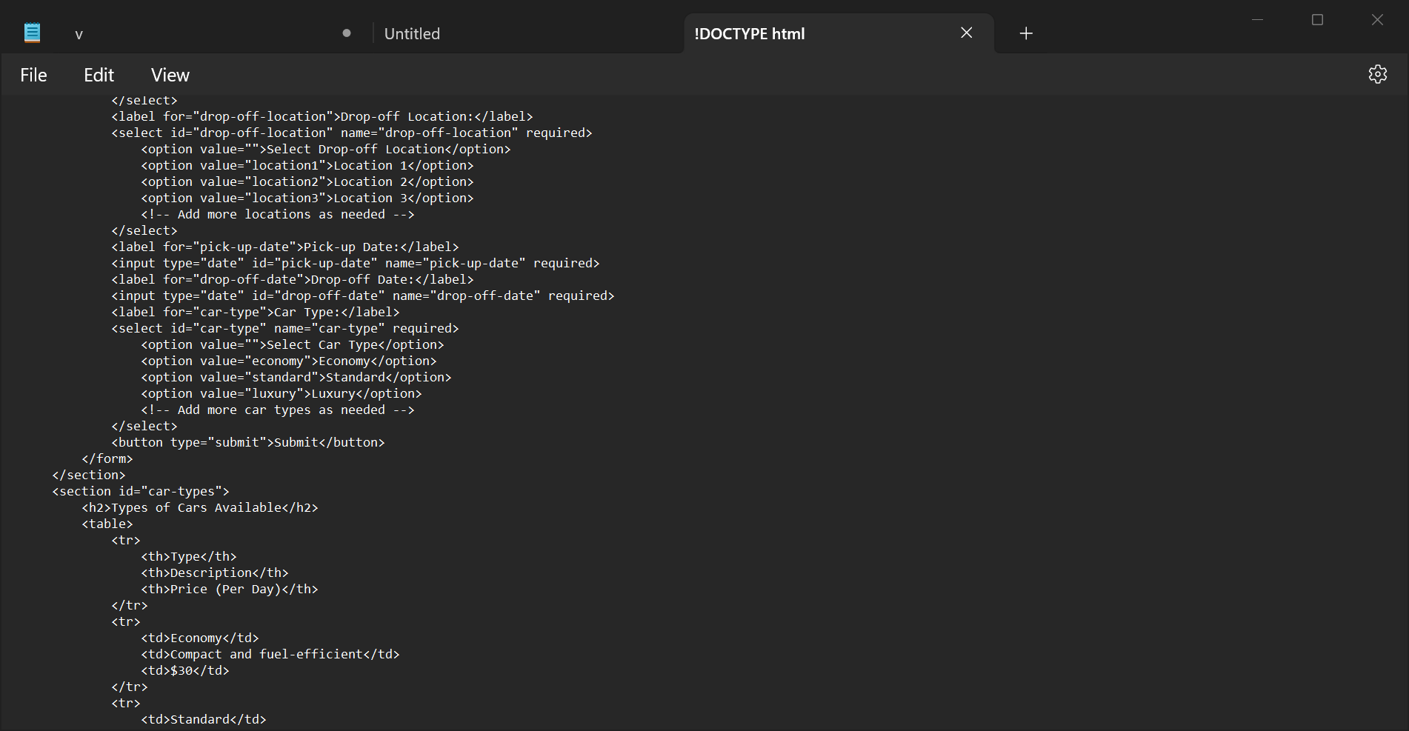

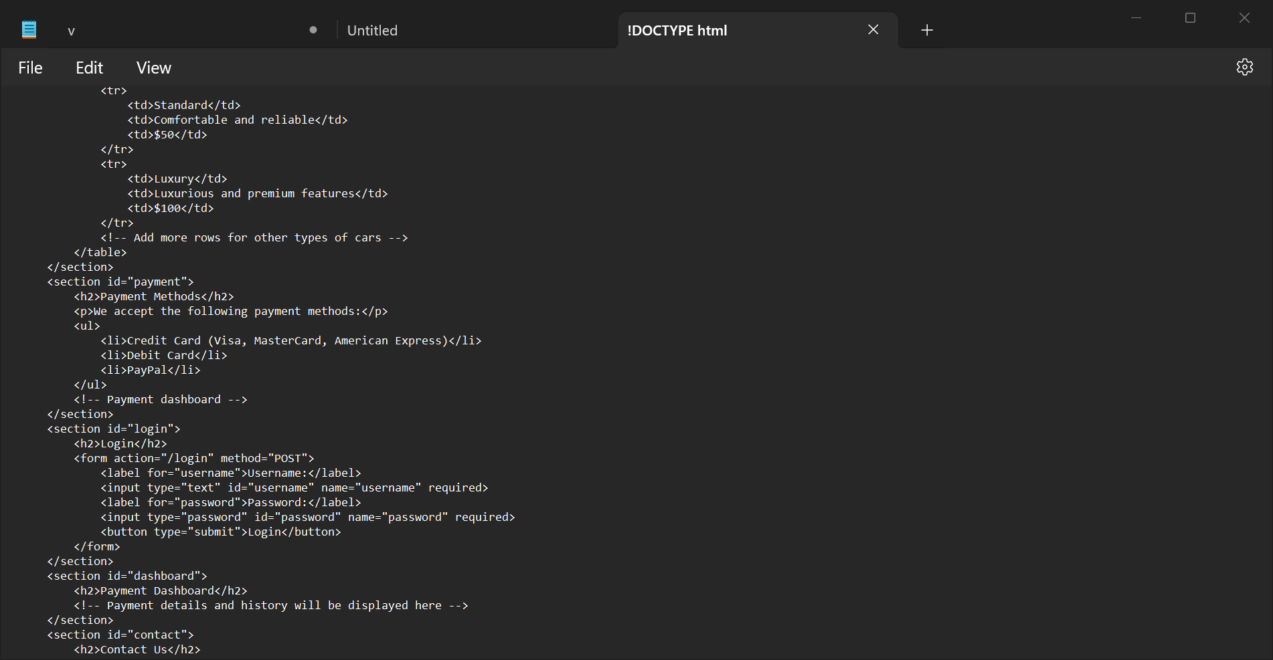

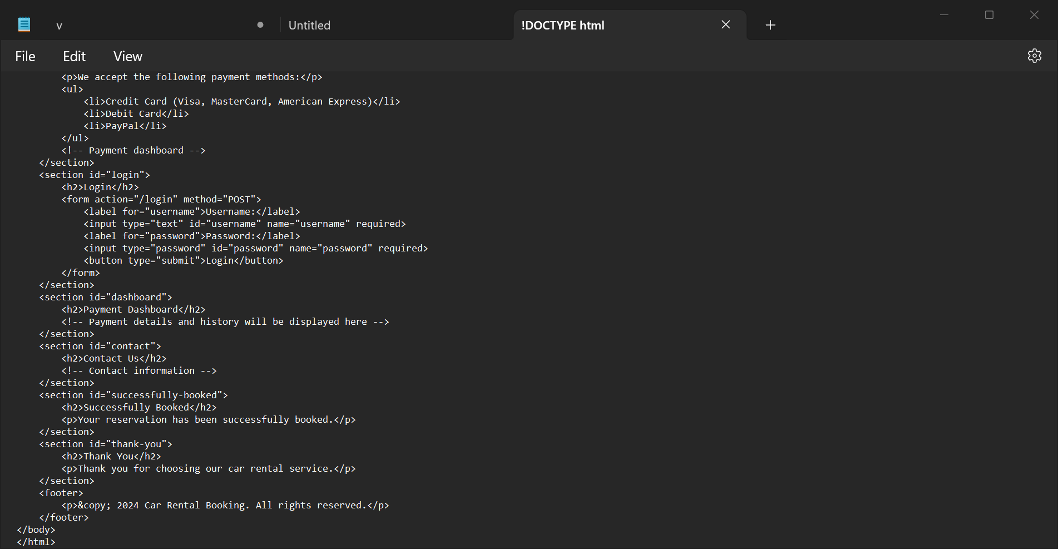



**SCREENSHOTS(OUTPUT)**

